**JS Advanced Retake Exam**

**Problem 1. Forum Posts**

**Environment Specifics**

Please, be aware that every JS environment may **behave differently** when executing code. Certain things that work in the browser are not supported in **Node.js**, which is the environment used by **Judge**.

The following actions are **NOT** supported:

* **.forEach()** with **NodeList** (returned by **querySelector()** and **querySelectorAll()**)
* **.forEach()** with **HTMLCollection** (returned by **getElementsByClassName()** and **element.children**)
* Using the **spread-operator** (**...**) to convert a **NodeList** into an array
* **append()** in Judge (use only **appendChild()**)
* **replaceWith()** in Judge
* **replaceChildren()** in Judge
* **replaceAll()** in Judge
* **closest()** in Judge

If you want to perform these operations, you may use **Array.from()** to first convert the collection into an array.

**Use the provided skeleton to solve this problem.**

**Note**: You **can't** and you have no permission to **change** directly the given HTML code (index.html file).

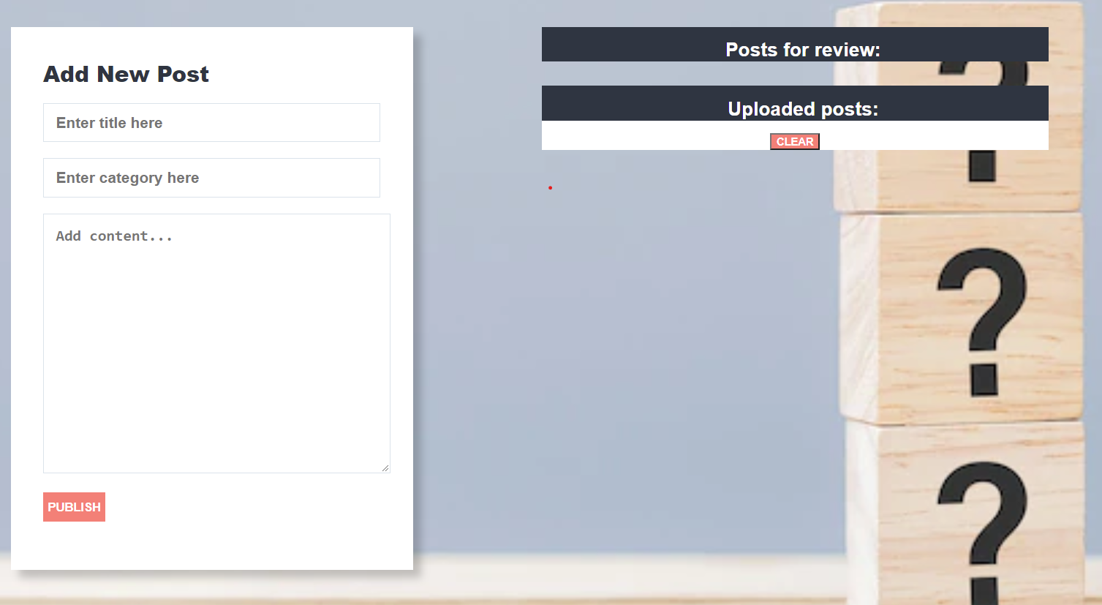

**Your Task**

**Write the missing JavaScript code** to make the **Forum** work as expected:

All fields **(title, category,** and **content)** are **filled with the correct input**

* + **Title, category,** and **content** are **non**-**empty** **strings**. If any of them are empty, the program should not do anything.

1. **Getting the information from the form**

When you click the **["Publish"]** button, the information from the input fields must be added to the **ul** with the **id** **"review-list"** and **then clear input fields**.

The HTML structure looks like this:

Картина, която съдържа текст

Описанието е генерирано автоматично

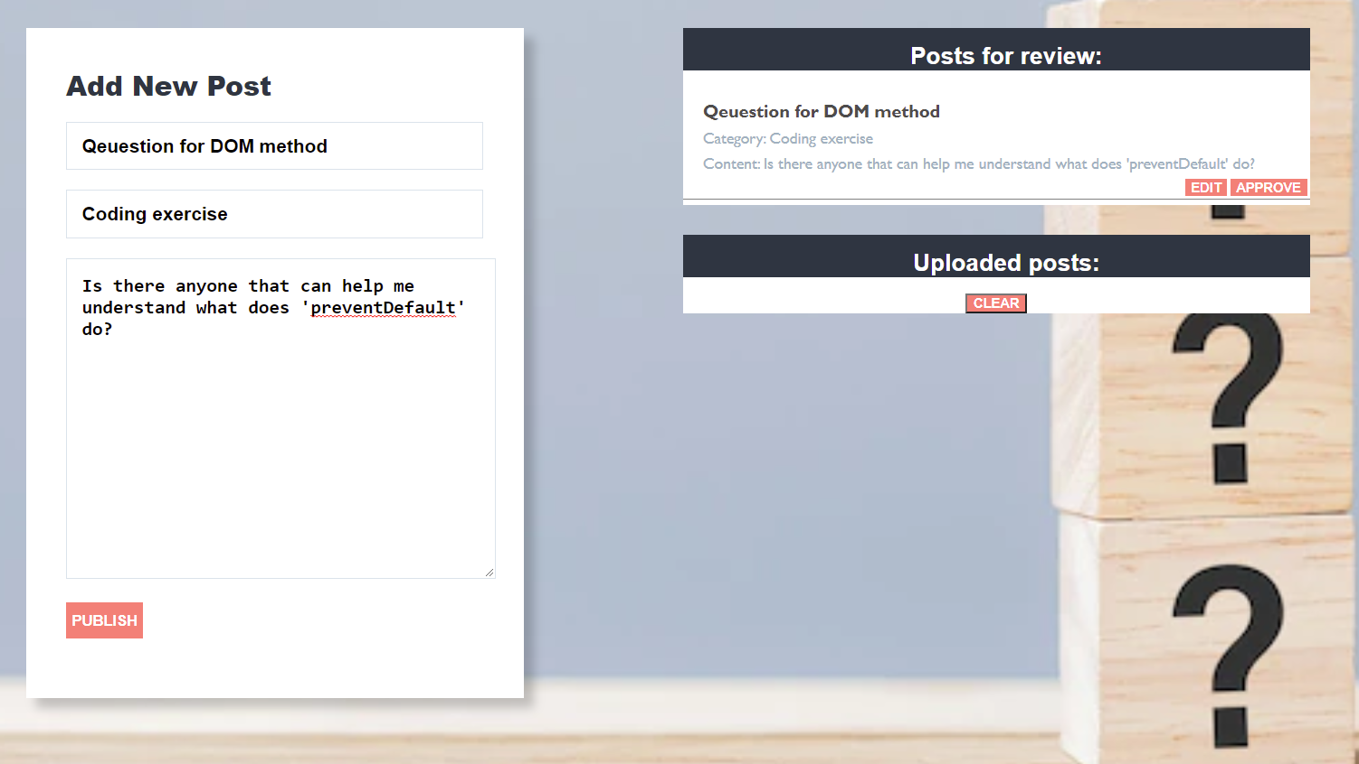

# Edit information for posts

When the **["Edit"]** button is clicked, the information from the post must be sent to the input’s fields and the record should be deleted from the **ul** **"review-list"**.

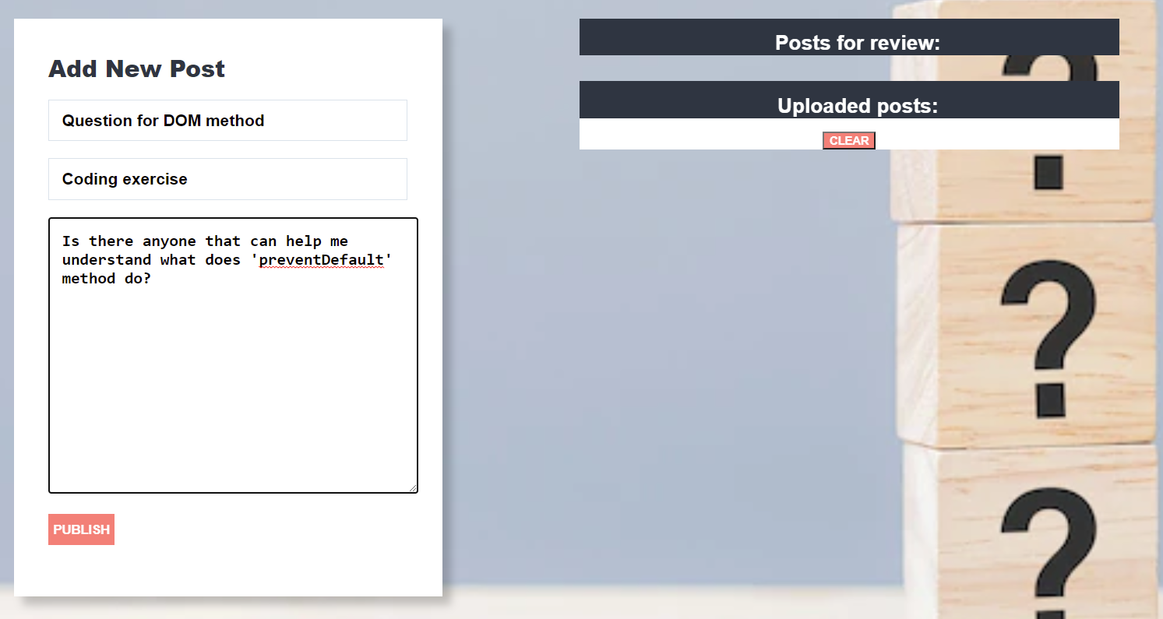

After editing the information make a new record to the **ul** with updated information.

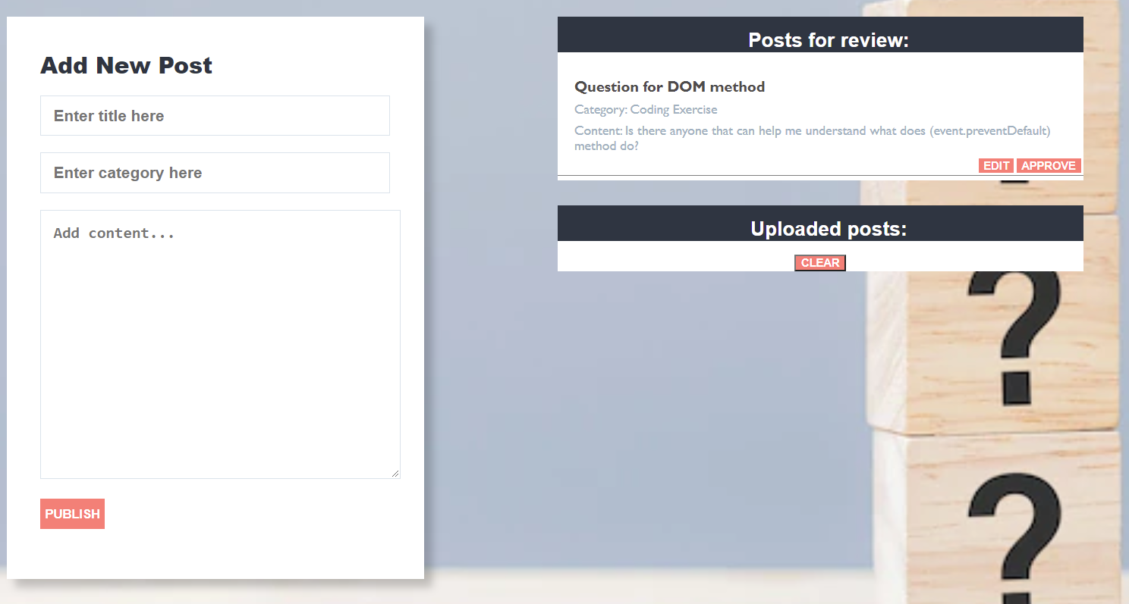

# Approve posts

When you click the **["Approve"]** button, the record must be **deleted** from the **ul** with **id "review-list"**and appended to the **ul** with the **id** **"published-list"**

The **buttons [“Edit”]** and **[“Approve”]** should be removed from the **li** element.

Картина, която съдържа текст

Описанието е генерирано автоматично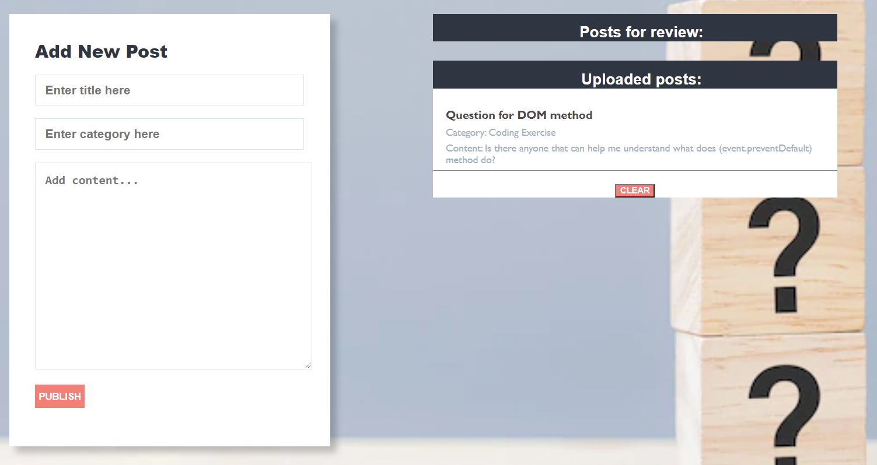

# Clear posts

When you click the **["Clear"]** button, the record for all posts must be **deleted** from the **ul** with the **id** **"published-list".**



**Submission**

Submit only your **solve()** function.

*GOOD LUCK… ☺*